A000-Paleo-Australopithecus afarensis-3.4 mya

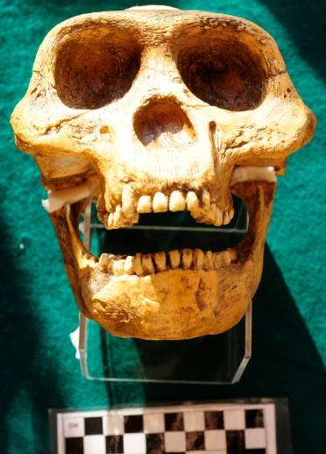

Paleo-Australopithecus afarensis-3.4 mya

**Accession Number:**

**Formal Label:**

**Display Description:**

**LC Classification:**

**Date or Time Horizon:**

**Geographical Area:**

**Map:**

**GPS Coordinates:**

**Cultural Affiliation:**

**Medium:**

**Dimensions**:   
**Weight:**

**Provenance:**

**Condition:**

**Discussion:**

**References:**